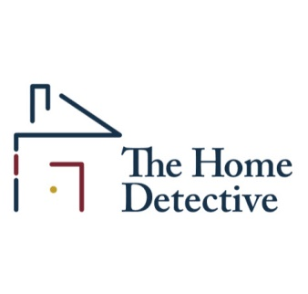
The Home Detective is expanding and we are looking for additional inspectors to help us service our growing clientele. If you think you might have what it takes to be an outstanding home inspector, please complete the following questionnaire, in full, and email it to info@thehomedetective.net. If we like what we see, we will get back to you.

First I need you to install Jing on your computer. http://www.techsmith.com/jing.html
Please take this typing test and use Jing to share your results… post link below. Typing test:
http://goo.gl/etfk7O For Example: http://goo.gl/cCtwPG
Type in your Adjusted Speed WPM here:

NAME: DATE:
1. We will do a criminal and credit background check. What are we likely to find?

2. Describe what you do now to earn a living. What are your average annual earnings over the last five years?

3. Describe what a home inspector does, and why you would be a good one.

4. Where do you live?

5. Do you have an active WA State Home Inspector’s license? If not, are you working on getting one? If yes, when do you expect you will have it?

6. Describe the vehicle you drive?

7. Have you ever had an attack of claustrophobia? What did you do to get past it?

8. Describe your experience with computers. PC? Apple?

9. Crawlspace/Attic: Are you comfortable in confined spaces?

10. What would prevent you from working on Saturdays, if needed?

12. Do you have any re-occurring personal commitments that might limit your work schedule?

13. Where will you find the money to invest in the proper inspection tools and gear?

14. How best do you learn? Reading? Watching videos? Hands-on?

15. How will you pay your bills while you are in training, and working towards a full schedule of inspections?

16. Do you have a “smart-phone”? If so, what kind?

18. What is your definition of being “on time” for an appointment?

19. What are your greatest strengths in dealing with people?

20. What do you do in your free time?

21. Are you bi-lingual? If so, what languages do you speak?

22. Any physical limitations with performing roof and or crawlspace inspections?

23. How do you respond when you are criticized?

24. What draws you to this profession? What about this business will get you up every morning? What do you hope to get out of performing home inspections?

